IT RCSA Audit Documentation
Implement & Deployment – BSI.IT.23.C25
Design Assessment, Walkthrough and Sample of One (DH 3264 NDF – Release 01 RLSE1270306) – re-performed with the 10/30/2026 evidence
DESIGN RATING | SAMPLE RLSE1270306 | CPA RATING | OBSERVATIONS
SATISFACTORY | PASS | SATISFACTORY | OBS-10, OBS-11

Control | BSI.IT.23.C25 – COTS Implement & Deployment (Heracles ID 50541461) – Key, Manual, In every operation
Risk | BSI.IT.23.R6 Improper Coding Practices (Inherent Moderate)
Review period | 09/01/2025 – 08/31/2026 (Cycle 2, scheduled 10/01/2026 – 10/31/2026)
Test date / tester | 10/30/2026 – IT RCSA
Walkthrough | 08/13/2025 – Jose Luis Martinez Avial, Systems Development Director (prior cycle). 2026 confirmation with the control owner to be obtained in the 2026 walkthrough.
Sample of one | DH 3264 NDF – Release 01, RLSE1270306 / CHG002670462 – production 01/28/2026 02:40
Evidence folder | C25 Implement Deploy\CDA and C25 Implement Deploy\CPA (BSI.IT.23.C25.01 – C25.13); 10/30/2026 files identical to those filed (MD5)

1. Design Effectiveness Summary
The control design is effective. The control is triggered by every production release of an SDLC project ("In every operation"): the developers document the Project Implementation Plan (PIP) / Deployment Plan – implementation tasks, components to promote and rollback – and attach it to the ServiceNow release (RLSE) and change (CHG) tickets, where IT Development, the Development Director, Business, InfoSec (where applicable) and Change Management approve it before the deployment window. The control is preventive and placed immediately before deployment (process map steps 2.4 – 2.6), which is appropriate to mitigate improper deployment activities (R6). Manual nature is appropriate because the plan is prepared and approved by people; ServiceNow enforces the approval workflow.
HERACLES question | Answer | Rationale (2026)
1 Frequency / trigger | Yes | Every production release; plan approved before the change window.
2 Audit trail / evidence | Yes | PIP attached to RLSE/CHG; Approval List; work notes; CAB post-implementation review.
3 Policy alignment | Yes | SDLC process map steps 2.4 – 2.6 (C25.01) and Change Management process.
4 Thresholds | N/A | Applies to all releases.
5 Escalation | Full | Change not approved until documentation / testing complete; rollback executed if deployment issues.
6 Information reliability | Moderately Reliable | ServiceNow records; plans manually prepared and re-attached (versions).
7 Evidence obtainable | Yes | ServiceNow ticket export by PMO / Change Management.

2. WT Summary
No 2026 walkthrough meeting was held for this cycle. The design understanding is based on the walkthrough of 08/13/2025 with Jose Luis Martinez Avial (Systems Development Director), the 2026 process map (v2.0 Draft, 05/20/2026) and the release evidence. The 10/30/2026 package contained the same C25 files already tested on 10/21/2026 (MD5 match); they were re-inspected and results are unchanged.
Model walkthrough language (RCSA CDA Job Aid §4.1): On 10/30/2026, IT RCSA performed a Test of One for BSI.IT.23.C25 through inspection of RLSE1270306 / CHG002670462 (DH 3264 NDF Release 01), selected from the 4 production releases of the SDLC population for 09/01/2025 – 08/31/2026. The control is triggered by the production release and performed for every release by the T24 Development team (Guillermo Sanchez Rodriguez), approved by the Development Director (Jose Martinez Avial), Business (Ted Fernandez) and Change Management (Angela Rojas Molano). The tester reviewed the PIP "ND Deal" (core updates, BCON BDER001-RLSE1270306.ND.DEAL.01, routines, roles, COB jobs, snapshot rollback) and the ServiceNow Approval List, which demonstrate the plan was documented and approved before deployment on 01/28/2026 02:40. Evidence is retained in ServiceNow. If a deployment fails, the backout plan ("Restore the snapshot before COB") is executed and the CAB post-implementation review records the outcome. Additional iterations: the other 3 releases (workpaper). No design observations other than OBS-01 (process map Draft); the control is appropriately designed to mitigate R6.
Competency (Job Aid §4.4): the Development Manager and Development Director demonstrated, through the PIP and ticket work notes, an understanding of the deployment steps, rollback and approvals required; they hold the authority to approve T24 production changes. To be re-confirmed with the control owner.

3. Sample of One – RLSE1270306 (DH 3264 NDF R01)
Workpaper column | Value / conclusion | Evidence reference | Result
Sample ID | 2 (CPA row 54) – NDF R01 | Workpaper CPA tab | Pass
Release / change | RLSE1270306 / CHG002670462 – T24 NDF Project Release 1; planned start 01/28/2026 02:00 | C25.08; C25.09 | Pass
Plan documented – tasks | PIP "ND Deal": core updates check, BCON BDER001-RLSE1270306.ND.DEAL.01 install, record authorisation | C25.10 | Pass
Plan documented – components | Routines, roles / permissions and affected COB jobs listed | C25.10 | Pass
Plan documented – rollback | Snapshot before release; ticket backout "Restore the snapshot before COB" | C25.10; C25.08 p.1-3 | Pass
Approved before production | G. Sanchez Rodriguez 01/21/2026; J. Martinez Avial 01/27/2026; A. Rojas Molano 01/27/2026; Business (T. Fernandez) per work note | C25.08 p.5-9 | Pass
Post-implementation | CAB review 07/22/2026 – "successful no issue" | C25.08 p.6 | Pass

OBS-10 (was OI-06): for all four releases (including RLSE1270306, final PIP attached 01/28/2026 02:09 after the 01/27/2026 approvals) the final plan was attached after the last approval and earlier versions were deleted – confirmation requested from the control owner; see the C25 Testing Procedures.
Conclusion: the implementation plan for RLSE1270306 was documented with tasks, components and rollback and approved by the relevant stakeholders before production. The sample passes; no exceptions in the 4 releases tested.

NewTest Script coverage (workpaper tab "New Test Script")
Step | Test script step | Sample of one – answer | Result
1 | Obtain Evidence | Ticket, PIP and approvals obtained (re-checked 10/30/2026) | Completed
2 | Completeness & Accuracy | Release traced to DH 3264; independent release list not provided (OBS-11) | Pass – OBS-11
3 | Population & Scope | Production deployment – category Deployment | Completed
4 | Control Execution | Plan with tasks, components, rollback before prod | Pass
5 | Control Results | IT, Business and Change approvals before 01/28/2026 | Pass
6 | Exception Handling | None | Pass
7 | Escalation & Remediation | N/A | N/A
8 | Risk Mitigation | Deployment planned, reviewed and authorized | Pass
9 | Testing Coverage | Documented in workpaper (4 releases) | Completed

Appendix A – RLSE1270306 Evidence
Exhibit A1: ServiceNow Release RLSE1270306 – header (BSI.IT.23.C25.08, page 1)
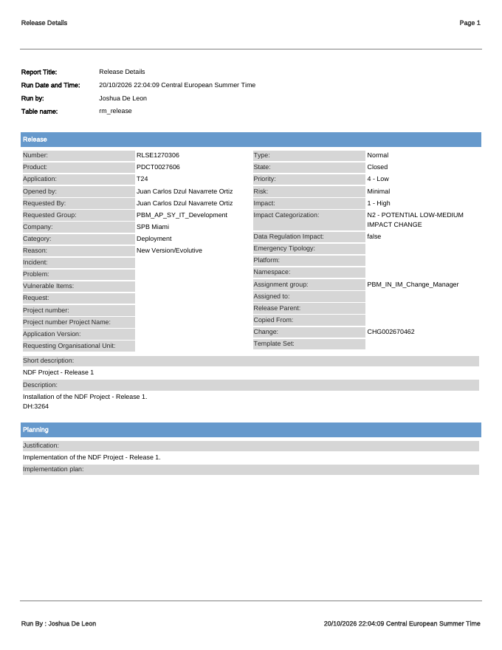
Source: BSI.IT.23.C25.08 – ServiceNow release ticket export (run by Joshua De Leon).
Exhibit A2: Approval List (BSI.IT.23.C25.08, page 7)
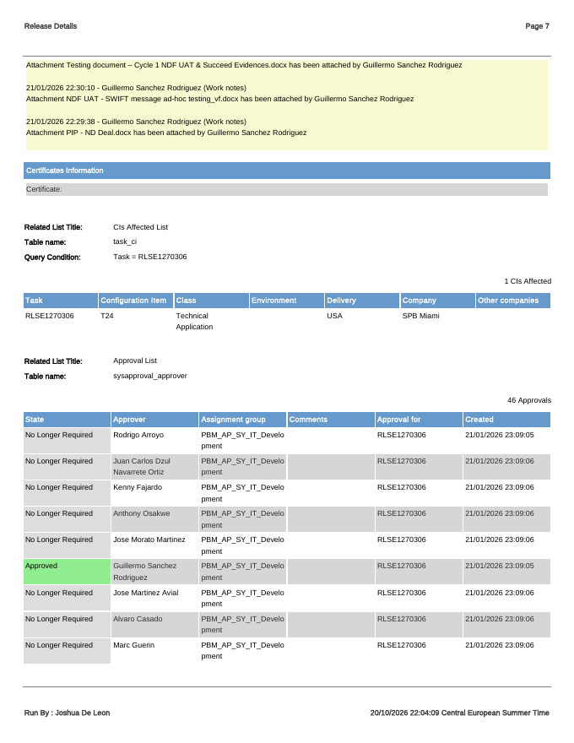
Source: BSI.IT.23.C25.08 – Approval List: approvals recorded before the 01/28/2026 deployment.
Referenced workbook: C25 WP 2026.xlsm – tab "Control Performance Assessment", row 54; tab "New Test Script".

